Circular Cross Sections

Definition
# Source: AI Source: Provided by: [Data Path: Persons Table -> ID Column: 1, Name_En Column: Motasem Essam] -> From: [ChatGPT] on [7/25/2026]
A Circular Cross Section is a two-dimensional circular region formed when a plane intersects a three-dimensional solid and the resulting boundary is a circle.
The cross section is a disk, consisting of all points inside and on the circular boundary. Its boundary is the circumference of the circle.
Circular cross sections commonly occur in spheres, cylinders, cones, and other solids with suitable circular symmetry or geometry.

Geometric Representation
# Source: AI Source: Provided by: [Data Path: Persons Table -> ID Column: 1, Name_En Column: Motasem Essam] -> From: [ChatGPT] on [7/25/2026]
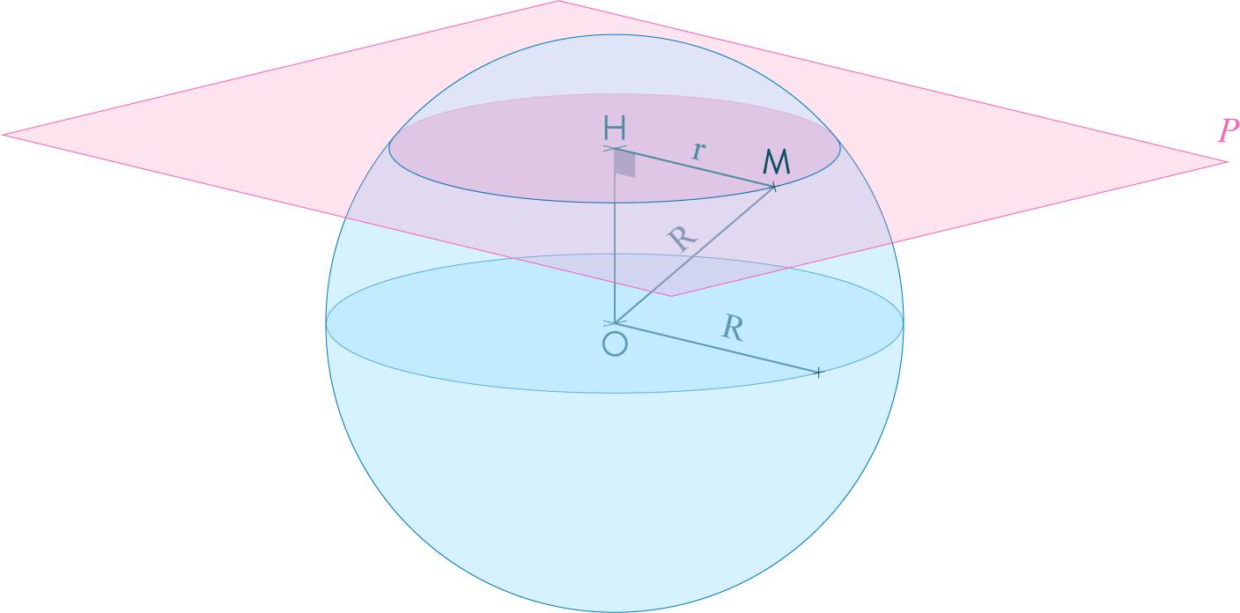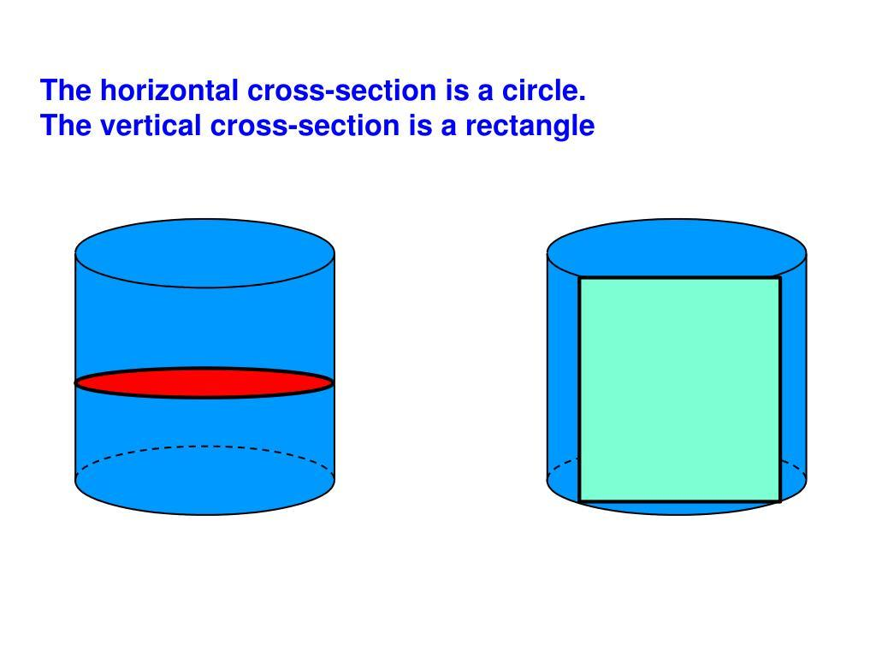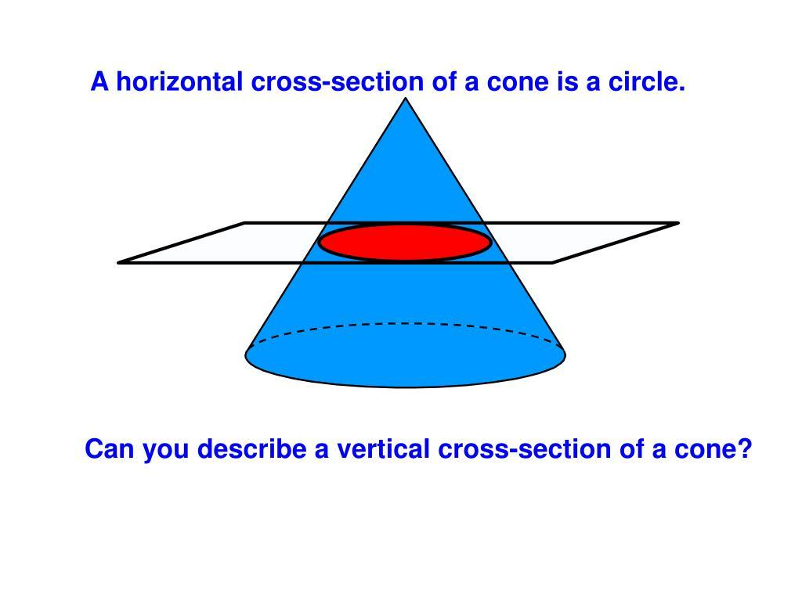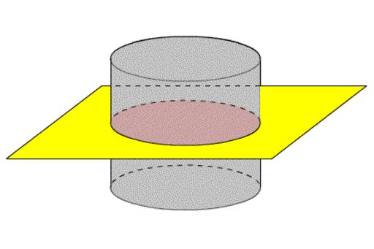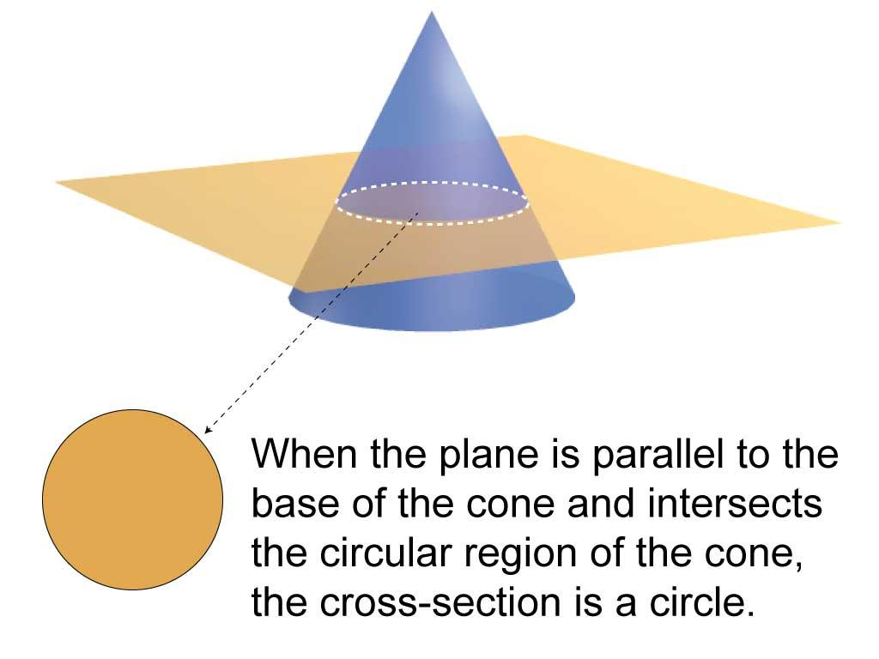

Geometric Structure
# Source: AI Source: Provided by: [Data Path: Persons Table -> ID Column: 1, Name_En Column: Motasem Essam] -> From: [ChatGPT] on [7/25/2026]
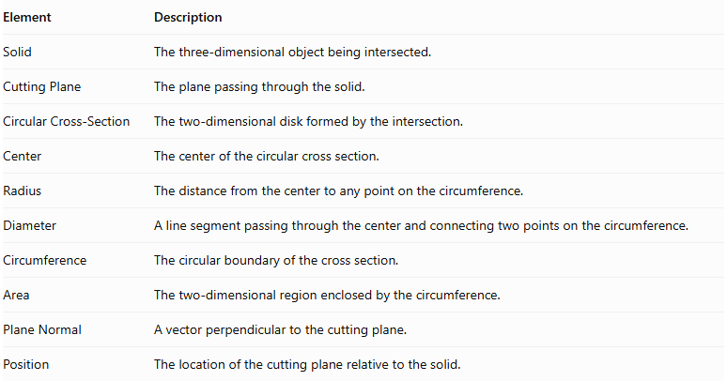
Element | Description
Solid | The three-dimensional object being intersected.
Cutting Plane | The plane passing through the solid.
Circular Cross-Section | The two-dimensional disk formed by the intersection.
Center | The center of the circular cross section.
Radius | The distance from the center to any point on the circumference.
Diameter | A line segment passing through the center and connecting two points on the circumference.
Circumference | The circular boundary of the cross section.
Area | The two-dimensional region enclosed by the circumference.
Plane Normal | A vector perpendicular to the cutting plane.
Position | The location of the cutting plane relative to the solid.

Main Characteristics
# Source: AI Source: Provided by: [Data Path: Persons Table -> ID Column: 1, Name_En Column: Motasem Essam] -> From: [ChatGPT] on [7/25/2026]
- The cross section is a circular disk bounded by a circumference.
- Every point on its circumference is at an equal distance from its center.
- Its shape is determined by the solid and the position and orientation of the cutting plane.
- Its radius determines its diameter, circumference, and area.
- Its area increases or decreases according to the position of the cutting plane.
- A circular cross section can be produced by horizontal, vertical, or oblique planes, depending on the solid.
- A tangent plane may produce a degenerate circular section with radius zero, consisting of a single point rather than a two-dimensional disk.

Types of Circular Cross Sections

According to the Position of the Plane

A. Central Circular Cross Section
# Source: AI Source: Provided by: [Data Path: Persons Table -> ID Column: 1, Name_En Column: Motasem Essam] -> From: [ChatGPT] on [7/25/2026]
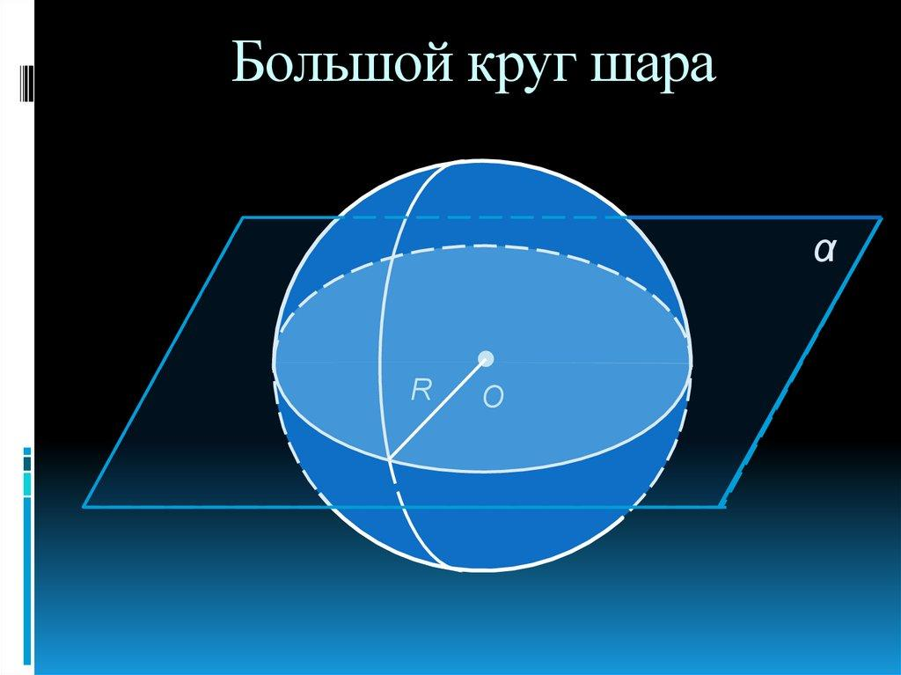
A central circular cross section is formed when the cutting plane passes through the center of a sphere or another suitable solid.
Characteristics:
- Passes through the center of the solid.
- For a sphere, it produces the largest possible circular cross section.
- Its radius equals the sphere's radius.
- In a sphere, it is called a Great Circle.

B. Off-Center Circular Cross Section
# Source: AI Source: Provided by: [Data Path: Persons Table -> ID Column: 1, Name_En Column: Motasem Essam] -> From: [ChatGPT] on [7/25/2026]
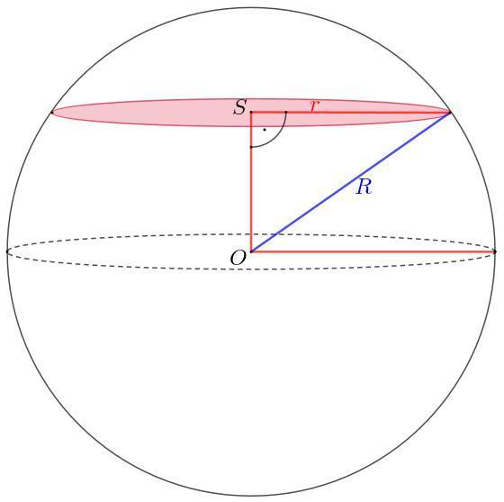
An off-center circular cross section is formed when the cutting plane intersects the solid without passing through its center.
Characteristics:
- Located away from the center of the solid.
- For a sphere, its radius is smaller than the sphere's radius.
- Its size depends on the perpendicular distance between the plane and the sphere's center.

C. Tangential Circular Intersection
# Source: AI Source: Provided by: [Data Path: Persons Table -> ID Column: 1, Name_En Column: Motasem Essam] -> From: [ChatGPT] on [7/25/2026]
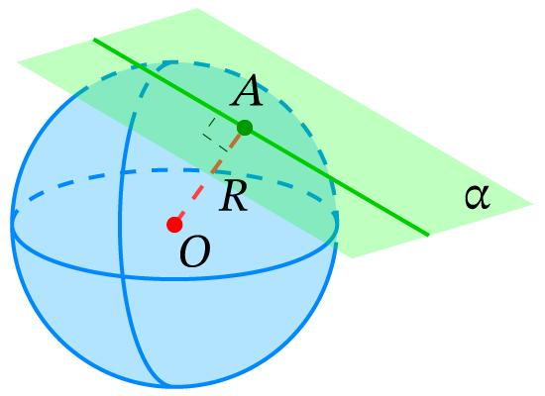
A tangential intersection occurs when the plane touches the solid at exactly one point.
- The intersection is a single point.
- Its limiting circular radius is zero.
- It is not a two-dimensional circular cross section.

Examples According to Solid Type

Sphere
# Source: AI Source: Provided by: [Data Path: Persons Table -> ID Column: 1, Name_En Column: Motasem Essam] -> From: [ChatGPT] on [7/25/2026]
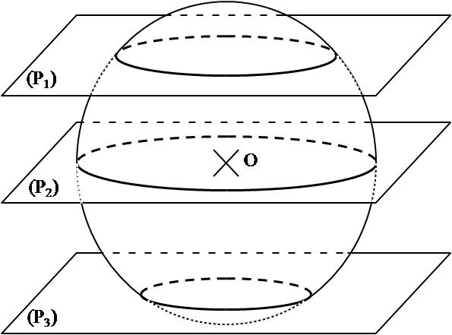
Any plane intersecting the interior of a sphere produces a circular cross section.
- A plane through the center produces a great circle.
- A plane away from the center produces a smaller circle.
- A tangent plane produces a single point.

Cylinder
# Source: AI Source: Provided by: [Data Path: Persons Table -> ID Column: 1, Name_En Column: Motasem Essam] -> From: [ChatGPT] on [7/25/2026]
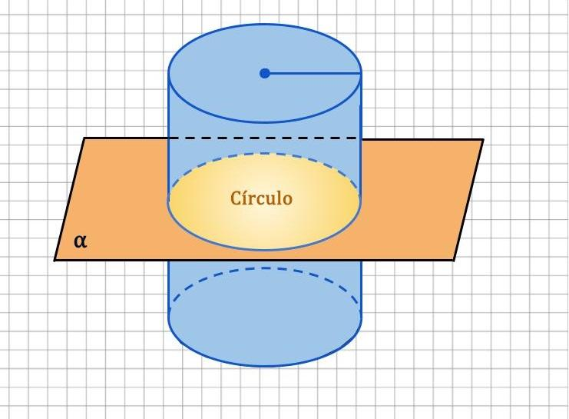
A plane perpendicular to the axis of a right circular cylinder produces a circular cross section.
- The section is congruent to the cylinder's circular base.
- Its radius remains constant along the cylinder's length.
- A plane inclined to the axis generally produces an elliptical section instead.

Cone
# Source: AI Source: Provided by: [Data Path: Persons Table -> ID Column: 1, Name_En Column: Motasem Essam] -> From: [ChatGPT] on [7/25/2026]
A plane parallel to the base of a right circular cone produces a circular cross section.
- The section is similar to the circular base.
- Its radius decreases as the plane approaches the apex.
- A plane passing through the apex and axis produces a triangular section instead.

Ellipsoid
# Source: AI Source: Provided by: [Data Path: Persons Table -> ID Column: 1, Name_En Column: Motasem Essam] -> From: [ChatGPT] on [7/25/2026]
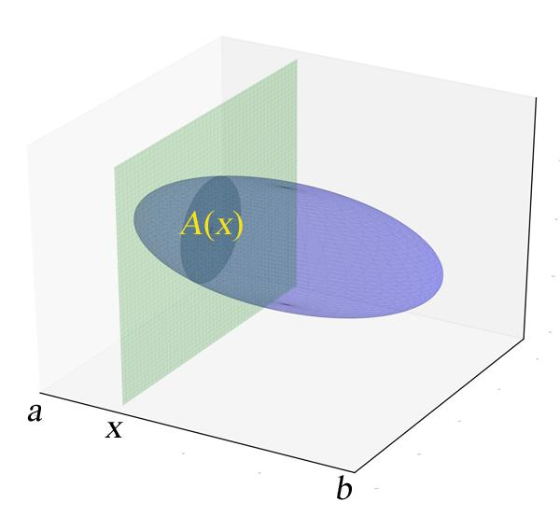
An ellipsoid can produce a circular cross section when the cutting plane has a suitable orientation and position.
For an ellipsoid of revolution, a plane perpendicular to its symmetry axis produces a circular section.

Torus
# Source: AI Source: Provided by: [Data Path: Persons Table -> ID Column: 1, Name_En Column: Motasem Essam] -> From: [ChatGPT] on [7/25/2026]
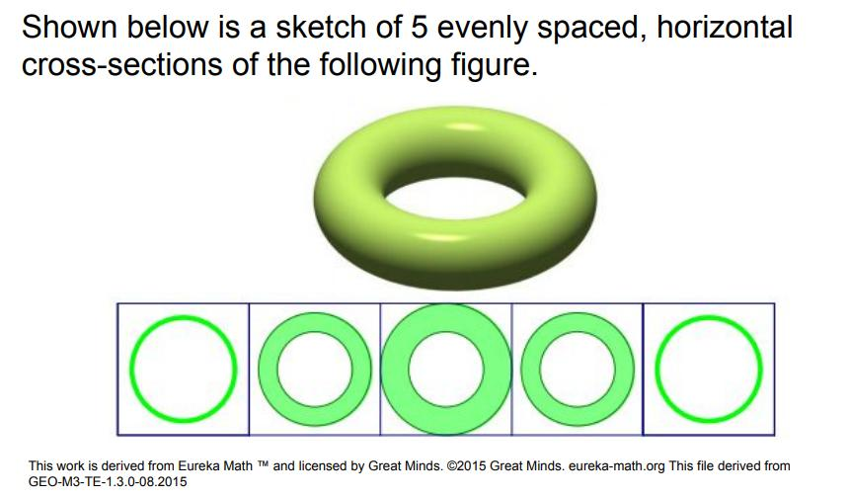
A torus can produce circular cross sections when intersected by suitable planes, such as horizontal planes perpendicular to its symmetry axis.
Depending on the height of the plane, the intersection may consist of:
- Two separate circles.
- One circle at a limiting position.
- No intersection outside the torus.
Important: A torus section consisting of two separate circles is not a single circular cross section; it is a cross section with two circular components.

Mathematical Representation

Circle Equation
# Source: AI Source: Provided by: [Data Path: Persons Table -> ID Column: 1, Name_En Column: Motasem Essam] -> From: [ChatGPT] on [7/25/2026]
A circular cross section in a two-dimensional coordinate system is represented by:
$$(x-h)^{2}+(y-k)^{2}=r^{2}$$
Where:
- $h,k$ = coordinates of the center.
- $r$ = radius.
- $x,y$ = coordinates of points on the circumference.

Area
# Source: AI Source: Provided by: [Data Path: Persons Table -> ID Column: 1, Name_En Column: Motasem Essam] -> From: [ChatGPT] on [7/25/2026]
The area of a circular cross section is:
$$A=πr^{2}$$

Circumference
# Source: AI Source: Provided by: [Data Path: Persons Table -> ID Column: 1, Name_En Column: Motasem Essam] -> From: [ChatGPT] on [7/25/2026]
$$C=2πr$$

Diameter
# Source: AI Source: Provided by: [Data Path: Persons Table -> ID Column: 1, Name_En Column: Motasem Essam] -> From: [ChatGPT] on [7/25/2026]
$$D=2r$$

Sphere Cross-Section Radius
# Source: AI Source: Provided by: [Data Path: Persons Table -> ID Column: 1, Name_En Column: Motasem Essam] -> From: [ChatGPT] on [7/25/2026]
For a sphere with radius $R$, intersected by a plane at perpendicular distance $d$ from its center:
$$r=\sqrt{R^{2}-d^{2}}$$
Where:
- $R$ = radius of the sphere.
- $d$ = perpendicular distance from the sphere's center to the plane.
- $r$ = radius of the circular cross section.
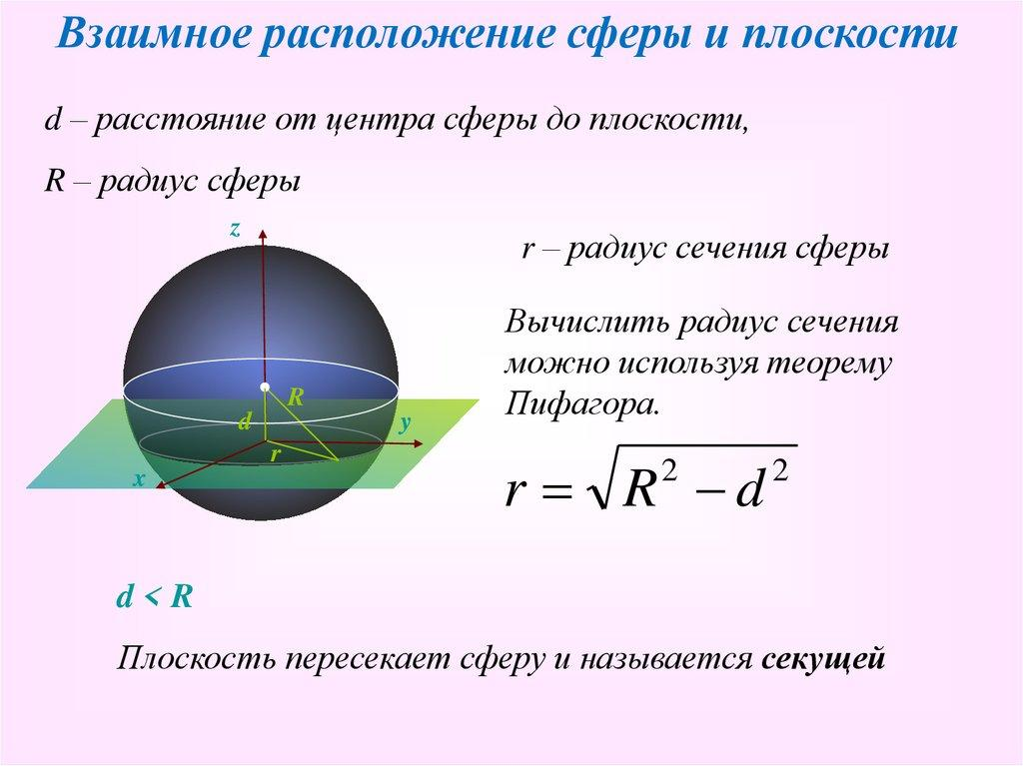
Special cases:
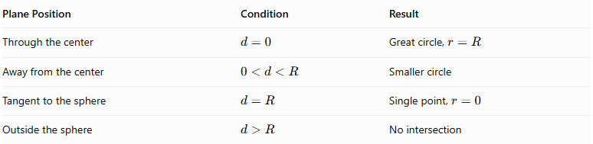
Plane Position | Condition | Result
Through the center | $$d=0$$ | Great circle, $r=R$
Away from the center | $$0<d<R$$ | Smaller circle
Tangent to the sphere | $$d=R$$ | Single point, $r=0$
Outside the sphere | $$d>R$$ | No intersection

Cone Cross-Section Radius
# Source: AI Source: Provided by: [Data Path: Persons Table -> ID Column: 1, Name_En Column: Motasem Essam] -> From: [ChatGPT] on [7/25/2026]
For a right circular cone, a plane parallel to its base produces a circular section.
Using similar triangles:
$$\frac{r}{R}=\frac{x}{H}$$
Therefore:
$$r=\frac{Rx}{H}$$
Where:
- $R$ = radius of the cone's base.
- $H$ = height of the cone.
- $x$ = distance from the apex to the cutting plane, measured along the axis.
- $r$ = radius of the circular cross section.

Mathematical Properties
# Source: AI Source: Provided by: [Data Path: Persons Table -> ID Column: 1, Name_En Column: Motasem Essam] -> From: [ChatGPT] on [7/25/2026]
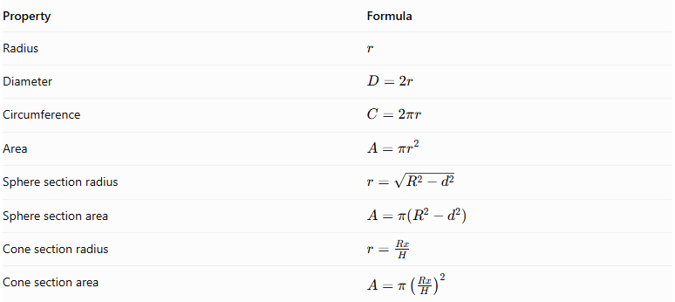
Property | Formula
Radius | $$r$$
Diameter | $$D=2r$$
Circumference | $$C=2πr$$
Area | $$A=πr^{2}$$
Sphere section radius | $$r=\sqrt{R^{2}-d^{2}}$$
Sphere section area | $$A=π(R^{2}-d^{2})$$
Cone section radius | $$r=\frac{Rx}{H}$$
Cone section area | $$A=π{\left(\frac{Rx}{H}\right)}^{2}$$

Circular Cross Section vs. Other Cross-Section Shapes
# Source: AI Source: Provided by: [Data Path: Persons Table -> ID Column: 1, Name_En Column: Motasem Essam] -> From: [ChatGPT] on [7/25/2026]
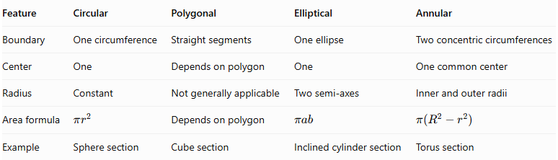
Feature | Circular | Polygonal | Elliptical | Annular
Boundary | One circumference | Straight segments | One ellipse | Two concentric circumferences
Center | One | Depends on polygon | One | One common center
Radius | Constant | Not generally applicable | Two semi-axes | Inner and outer radii
Area formula | $$πr^{2}$$ | Depends on polygon | $$πab$$ | $$π(R^{2}-r^{2})$$
Example | Sphere section | Cube section | Inclined cylinder section | Torus section

Applications
# Source: AI Source: Provided by: [Data Path: Persons Table -> ID Column: 1, Name_En Column: Motasem Essam] -> From: [ChatGPT] on [7/25/2026]
- Engineering: Analyzing cylindrical and spherical components.
- Architecture: Designing columns, circular structural members, and curved structures.
- Manufacturing: Determining the shape of circular cuts in pipes, rods, and cylindrical parts.
- Medicine: Understanding circular slices in CT and MRI imaging.
- Geography: Studying great circles and smaller circles on spherical models of Earth.
- Mathematics: Calculating areas, radii, and volumes using cross-sectional methods.

Main Classification
# Source: AI Source: Provided by: [Data Path: Persons Table -> ID Column: 1, Name_En Column: Motasem Essam] -> From: [ChatGPT] on [7/25/2026]
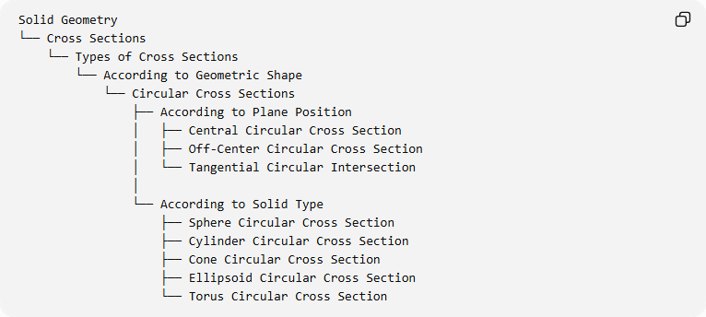
Solid Geometry
└── Cross Sections
└── Types of Cross Sections
└── According to Geometric Shape
└── Circular Cross Sections
├── According to Plane Position
│ ├── Central Circular Cross Section
│ ├── Off-Center Circular Cross Section
│ └── Tangential Circular Intersection
│
└── According to Solid Type
├── Sphere Circular Cross Section
├── Cylinder Circular Cross Section
├── Cone Circular Cross Section
├── Ellipsoid Circular Cross Section
└── Torus Circular Cross Section

Key Points
# Source: AI Source: Provided by: [Data Path: Persons Table -> ID Column: 1, Name_En Column: Motasem Essam] -> From: [ChatGPT] on [7/25/2026]
- A circular cross section is a circular disk formed by the intersection of a plane and a solid.
- Its boundary is a circle.
- A sphere produces a circular section for every plane that intersects its interior.
- A central section of a sphere is a great circle.
- A right circular cylinder produces a circular section when the plane is perpendicular to its axis.
- A right circular cone produces a circular section when the plane is parallel to its base.
- An ellipsoid of revolution can produce circular sections perpendicular to its symmetry axis.
- A torus can produce multiple separate circular components in one plane section.

Conclusion
# Source: AI Source: Provided by: [Data Path: Persons Table -> ID Column: 1, Name_En Column: Motasem Essam] -> From: [ChatGPT] on [7/25/2026]
Circular Cross Sections are two-dimensional circular regions formed by intersecting suitable three-dimensional solids with planes. Their dimensions depend on the geometry of the solid and the position and orientation of the cutting plane. They are particularly important in the study of spheres, cylinders, cones, ellipsoids, and toruses.

